MANUAL

How to initialize the U 952

1 st: Start the program „Network Enabler Administrator“:

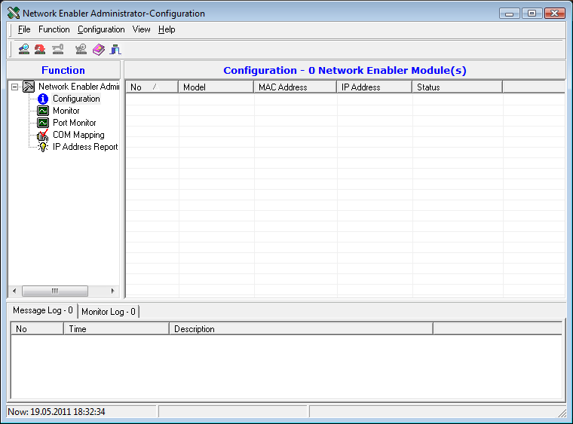
2 nd: Broadcast search

The following window appears and disappears after finished search:

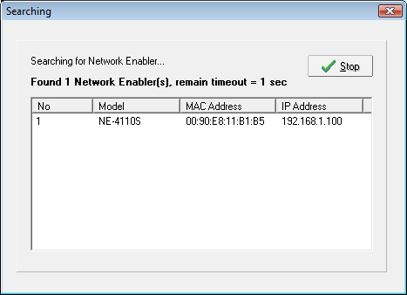

At „Configuration“ the device will be displayed

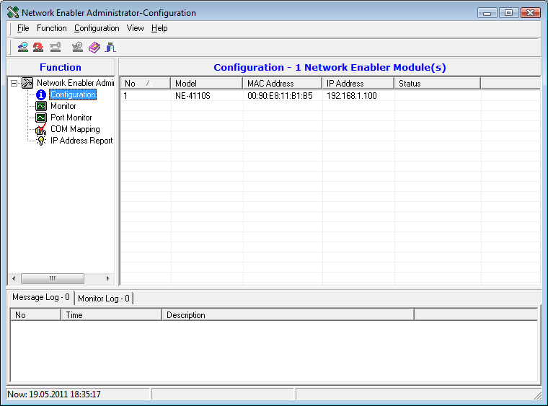
3 rd: Click on „COM Mapping“

The following window appears:

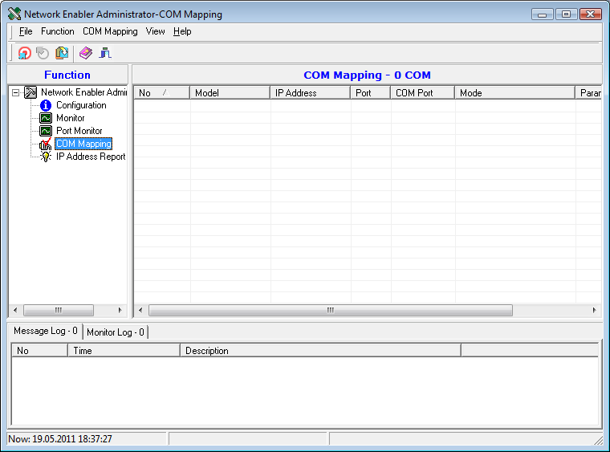

4 th: Make a right mouse click on “COM Mapping” and choose the option “Add target”

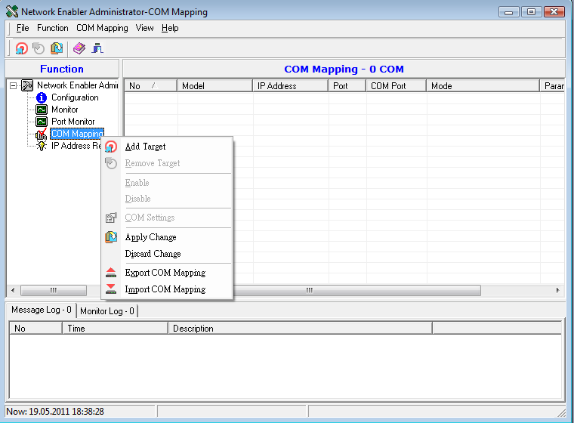

The view will change like on next picture:

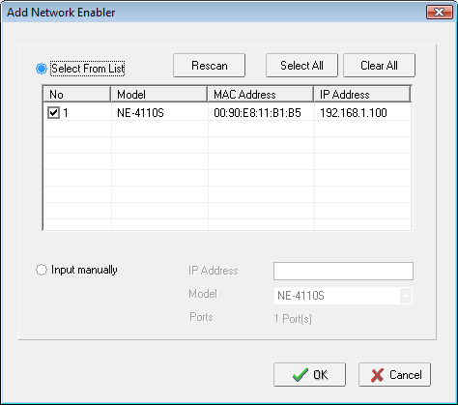
5 th: Click on OK

Than the target is added:

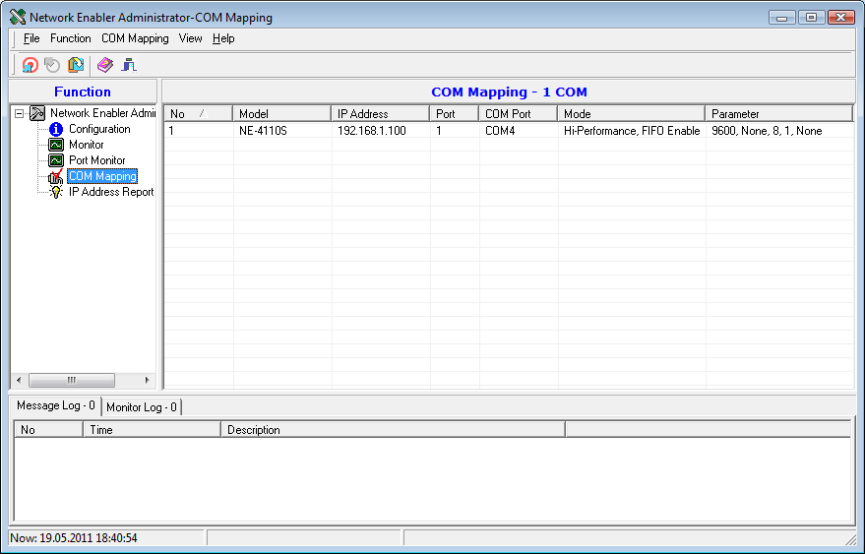
COM 4 will be emulated

6 th: Start HE programming Software and create a new project like below:

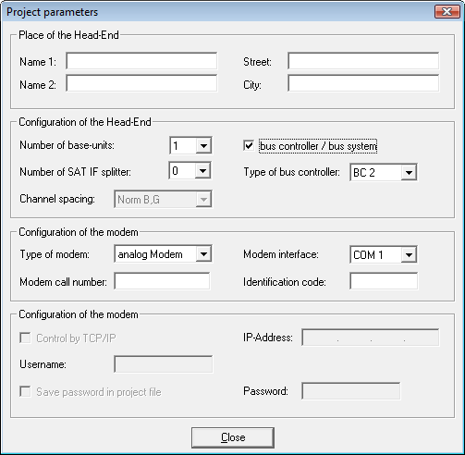

7 th: Choose as COM port “COM 4” like in the example

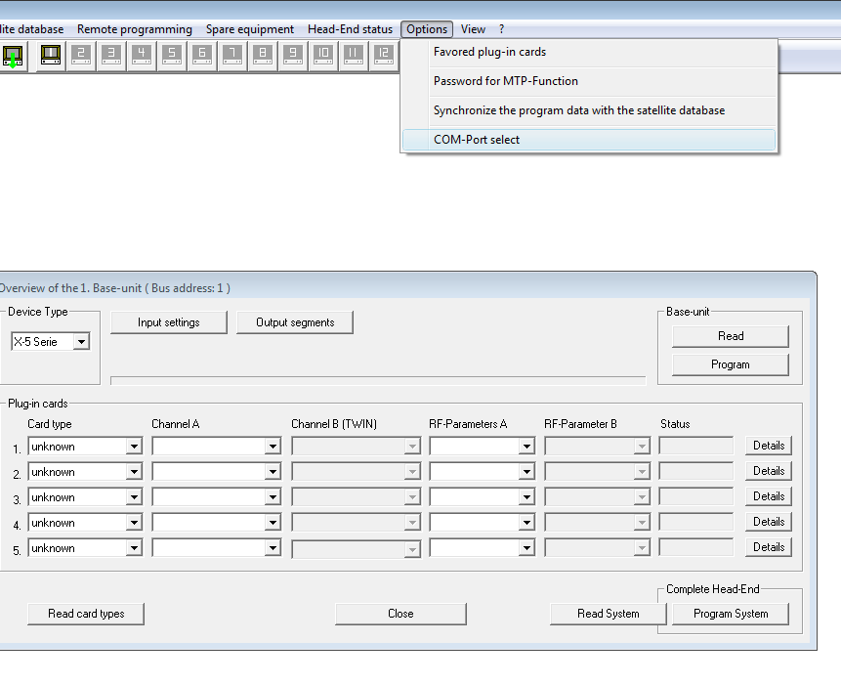
8 th: Change to COM 4:

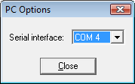

9 th: If the message “COM 4 can not be opened” occurs, please close HE programming software and retry. I experienced this error message as well and after restarting the HE programming software it worked. ☺

